Name: Janna Riel M. 0rcelino

Section: 9 Calcium



**NAVIGATE**

*Note: This is an* ***ALTERNATIVE*** *assessment.*

We now go back to the picture you took at the start of this module. Print and paste it on the space below and describe how the unifying themes of Biology just discussed were apparent.

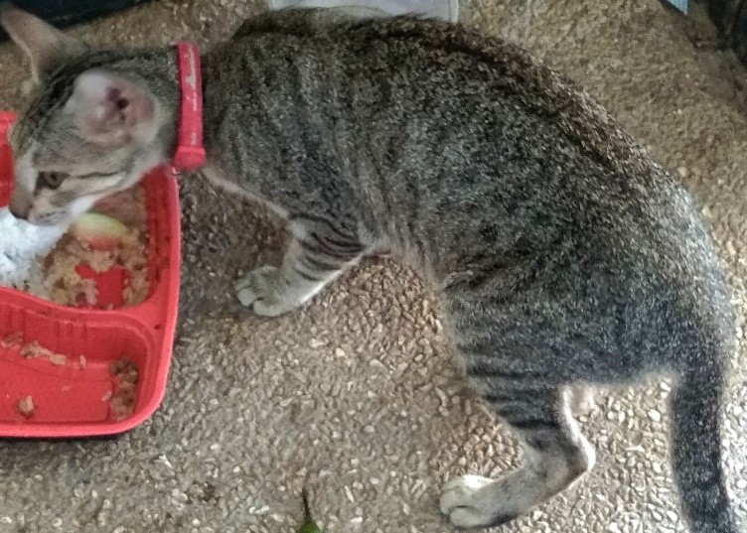

Cats, just like any animal, consists of a series of hierarchal parts. They are the organelles, cells, tissues, organs, organ system, and the organism itself, the cat. They also interact with other cats, forming a population of cats. Adding the Plants and other animals around (eg. Birds, pigeons, butterflies, etc..) they would create a community of living beings. The place I took the photo in, the school itself, is the Ecosystem.

**Information**

All life forms use a set of combined nucleotides

(codon), for a single amino acid that will be used to create protein.

**Energy and Matter**

All organisms require energy to work. Cats

obtain energy through what they eat.

**Interaction**

Cats interact with both biotic and abiotic things.

They also have a range of different Symbiotic Relationship like; Parasitism of a flea and the cat, commensalism/ mutualism of humans to cats, etc.

**Evolution**

Cats are from a common ancestor that adapted

and changed through time creating different cat species and the domestic cats that we, for sure, know.

Biology 1**: FUNDAMENTALS OF BIOLOGY 1**

Page **5** of **10**